^{ffi,} ffi ^{c!&ffrlG} q-J
<t(qtcq't cq-rqD
^{rti,tdt,} Gns tq, tooa
^{'r.lqFlstl} rl.5nF1 c{dr
afih _{i$ir,} ^{,fa} trinr s c{ir cCdcr
{ii{{.rrfu
(ciR-r't$)
c6l'fi
^{ElBi,} )e .it{ lsjvtl ^{Ffis} $oa
_{'sr,} ^{q?,} r ₍ ^{g3GqEviooc} _{f iB{q Ffr i.4r{,F} ^{qRi,} _{rodr} (\oo) rr{r ))r( cRi _{cn {m rw F} ^{q5s} TT6R.n {tr'lr lBriq fiF aidn'lr firf'r hli'r4, _{toot} ^{qr} _{fr{fi cl{@} ^{qlr,llrr} _{El?n,} ^{qqt} F
tqR-!6 fif{:'l|n-
(9 ffi \ _{e E{ (r)} q ^{,fr} hT{,r E{r (11) .rr! E{< Fr}N Eftfts ,qtuF nF.!fiq rt(<, {ql r-
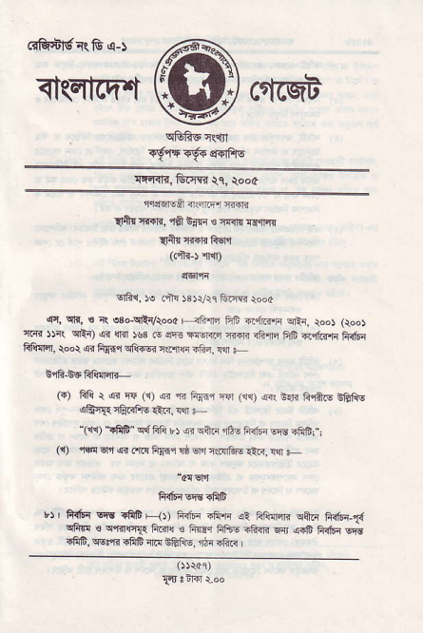
_{"(1{)} ^{f.fltt"} c{ Eii $ '!? ^{qft.r} ffi! airF €E iffEi!
₆₎ rw _{Elrl} ^{q} _{cfi F{*r r}} ^{qn} r(crtu €R, !!i F
"arstrt
F{ElqrrnF
t) | Flfq lFfr _{.RG F-{t liifrr .Fir} ^{qt} _{FfiTlrlr} ^{qfti FF6r-t{} Effrq € sfiqr]3 fti{ € tu!,r F6e ifiar Fn ,{rb FRfF Eii {FF, i{q'n {fiG 4F B&1i8, rrrr aFR I
(3) G)
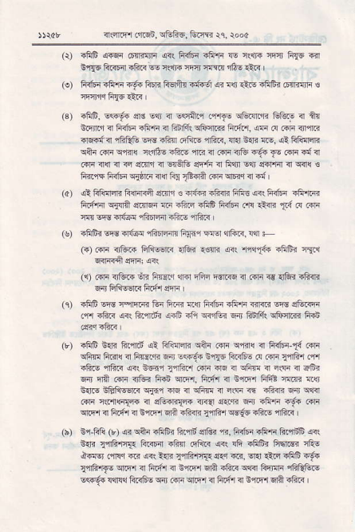
^{q{qrmr} _{riid,} ^{srFF6.} Fdfi4 \q, tod4
_{rliF} ^{(.qr} rEnnqnr .!+. FRlrr .fi'n Is rsn{ rqrr FTG €' Eq6 FftlFir aftr @ r..tF rlrr ffrir rA6 trs ,
nFf6ift'ri -!'. Flri Retu<tu <i !{r €rs -litrr n riur €
.frm. Esir sts E$ ir Eqnr'i _{.,riF} ^{qtuilrE} GtuE ir atr _{&6i.'r n fR1'r e1tui a Gnfii} qliqliir €@?. _{srr n F1i} qr,fr6 ^{rq€fa "3?,} _{"E} {5p dn' ^{{5F,} € }- nra. .!t tfffi _{ctn @ mb FXe} ^{6,ae} _{rc} ^{d} _{@F} tr'D ^{r.t+} _{fu} @ € d .+]i 4!r ir <s e.nd n ^{6roB} eF4i 3r F!]l E?[ effr;n _{!r} \f{r{ s _{1i{q5 tufq} ^{qjt ii'!r Fr} _{tffi} (.F ^{q6} !rF,l
aiFlilFrr?fi{F]ias4r,1€q{a?iftii<Ffiq@rFRf6n .li'r@ F4t'- 'jd niF {i 4?.i 4tr tut'F eln ^{,}n} _{Td} @ @ wwiltur efiDr{n rftE,r6F I
FftE" @ d{@ ffirrmfiFj1 F{€r arft1 !'n + 6,@ _{dna} ^{qt54.'lB} .w !..,qaf. dtri 'lrn
_{LrJ} .6F _{??r" ft} ^{+rn-} ₆ ^{Etu} 4n"d ? _{r{F € oh} 5?@ F, fiJiqEr.< F.{zi eni I
ifrF eE i-iftIra Gr ftR alr ndfrr ift']r .{e EFs sG.irr .,n dftu R\fu"ah !4, 4^ mr'R 6a Fru''14 €,;-F Fran
rfF e{r Bilrd !R _{Flclrffr cftr Gl]r c,B'(} ^{ql} F+dr-t{ .li'r ^{qfrr ftrl(} " Frci.ri sir !s9t s'lrq Fr<tu a .ira lrfi,r d'l
_{6.*,} ^{*?.i f.+@"} _{t,€..} r @ 4 r5p { ^{-s} 4 trin ^{qir qri} .+F r]tu _{hin} ^{qr.Er,} _{f|.l4r} ^{q} trEr FfE !l@ qlt sfle G?l}6@ s{}q @ ₄ ^{qiF} . ^{-s} { 65@ @ @
.rir rlr.ll'qlfrr n sli?F{|. nra ,iqrn 5{ di'E i9. 6F ^{qrF1} { F@1n BlEr ^{ErA sftilr} _{i'itu} wft !1iF {Frs E4F1i (r) € ^{qqr} _{.hlii ft'rd} q'R. ^{q?.} fRfr{ +li,lr ft{iF @. ^{s5<} _{lqfi'ff{q} ftorl ifrn &fR< @. rli ifrtrr Fiqris{ rftq l'aa .r. @ ^{ia n} _{flf.'@} E" @ ^{q{} .}.i i!5'n F E _{lqrB'rfE} ^{qr.Fr} <r ft6r <r E,i.F,i ^{6A} _{"ft<} ^{qr<r} _{Fir{fr} qFQtuo
EFqe _{r${'r ffis} ^{qir} _{RR} ^{q.Er} 4 6rfi rl Elilir 6l? rftr l
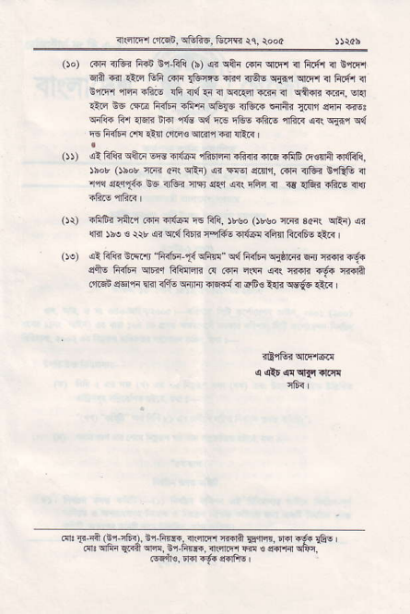
^{rn.?ftqr} _{fir(g!,} ^{qf6F5,} Grrr tc, roo(
oo) ..n ilk frs E,r-fill (b) ,sr cftr _{..f{} ^{qFl i Flett} " Erid.
d? 6r *i.r ^{&fr .{F} _{1tur6} -B'r _{{qE} ^{q{nr qir't} 1l fi.fi ir Eirqtr ^{i!fiqFb rfrir{arrlq{4.i!rT{} " ^{q+{f{i.n.} sr{
1lr EE _{.\i6liiftr 4fr'B} ^{q&r} {tu{ ^{!nr+{} _{!.!r'J} ^{qhrr} @r ^{qr&{} _{Fr} ^{qsR }d} _{"16 c{ !F} ^{qGq} rR.6 rfir{ @. _{Fr{r} q{ ^{q6} F_{ir{ .'rq €{ _{dm} ^{q."r} _{st} ^{q!r{} |
_{(D)} ^{qt} fili{ sqn sre ar4c! rRrcn ifr{r {rq.fiE mcrfi.r{R11. ^{)bor} _{osor crqi aR} qRo ,4r _{Esr} ^{qdin,} .fti l]E 6lRG a 'i'iq ^{q.1!q6{} E6 _{llE flTr .{ir} ^{q<(} ffiq i {4kiaftEqls
_{0r)} .F1Fi rn r rslr rl{6c F6 fi]i, )r!. ()wo _{r.qr scr(} qrtt q {r'l )bo € _{tt ,fr} ^{qdl} FIfd neiiE.lfdr ihfi Flrr6E !!i. l _{Oo)} ^{qt} Fli" &\! _{r} ^{'tuF-t{} qRln" q{tii6{ ^{qiJrT{} w cirr{ rfr _{sis liifF} ^{qaq} _{Fli{qn a c{lr r(tlr} ^{q{ {tr.n} _{4s} cr{ih _{oLd} ^{q6nr} _{lBr iffv} ^{qrnn} rn'{,d{ c.F! ln" w{s €.q I
^{r'} _{1c-{} (ci-?nrt, Gi+F, !I!r ^{4.ri} _{Eft.} r ^{.q.} r&! ' _{flr} qFi qdi ^{qE. Gr.Rrf..} {qF.l @ o _{{.mi} qFq
@ri]€. rd +6 lrdFs I

